BUSINESS PROBLEM
A digital wallet company wants to understand what drives Customer Lifetime Value (LTV). By analyzing customer demographics, transaction behavior, engagement, and satisfaction, the business aims to identify high-value customers, reduce churn risk, and optimize loyalty and retention strategies for long-term revenue growth.
Analysis Goals:
Goal 1: Identify High-Value Customers
- Insight: Helps business focus on premium users and retention campaigns.
Goal 2: Analyze Customer Segments by Demographics
- Insight: Enables targeted marketing and pricing strategies.
Goal 3: Understand Engagement vs Customer Value
- Insight: Justifies investment in product engagement features.
Goal 4: Evaluate Loyalty Program Effectiveness
- Insight: Measures ROI of loyalty and referral programs.
Goal 5: Identify Churn-Risk Customers
- Insight: Enables proactive retention actions.
Goal 6: Measure Impact of Customer Support & Satisfaction
- Insight: Supports CX improvement and support optimization.

SQL Queries Results
  - Total Customers:
Query: SELECT COUNT(DISTINCT Customer_ID) AS Total_Customers
FROM digital_wallet_ltv_dataset;
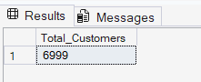
  - Average Customer Lifetime Value:
Query: SELECT ROUND(AVG(LTV), 2) AS Avg_ltv
FROM digital_wallet_ltv_dataset;
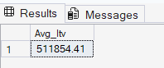
  - Average LTV by Income Level
Query: SELECT Income_Level, ROUND(AVG(LTV), 2) AS Avg_ltv
FROM digital_wallet_ltv_dataset
GROUP BY Income_level
Order by Avg_ltv DESC;
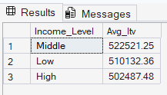
  - Top 10 customers by total spend:
Query: SELECT TOP (10) Customer_ID, LTV, Total_Spent
FROM digital_wallet_ltv_dataset
Order by Total_Spent DESC;
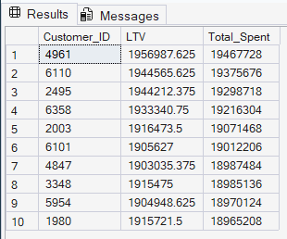

  - Engagement Impact on LTV:
Query: SELECT App_Usage_Frequency,ROUND (AVG(LTV), 2) as AVG_ltv
FROM digital_wallet_ltv_dataset
GROUP BY App_Usage_Frequency
ORDER BY App_Usage_Frequency DESC;
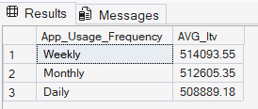
  - Churn Risk – High LTV but Inactive Customers
Query: SELECT Customer_ID, Last_Transaction_Days_Ago, LTV
FROM digital_wallet_ltv_dataset
WHERE LTV > (SELECT AVG(LTV) FROM digital_wallet_ltv_dataset)
AND Last_Transaction_Days_Ago > 300
ORDER BY LTV DESC;
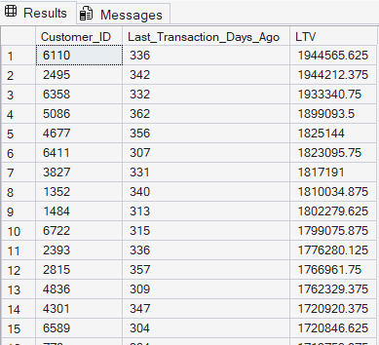
  - Support Quality VS Customer Value
Query: SELECT Satisfaction_group,
ROUND(AVG(LTV), 2) AS Avg_ltv
FROM (
SELECT
LTV,
CASE
WHEN Customer_Satisfaction_Score >= 4 THEN 'High Satisfaction'
WHEN Customer_Satisfaction_Score >= 3 THEN 'Medium Satisfaction'
ELSE 'Low Satisfaction'
END AS Satisfaction_group
FROM digital_wallet_ltv_dataset
) t
GROUP BY Satisfaction_group;
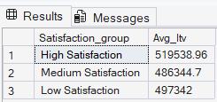

Dashboard Overview

Dashboard 1: Executive Overview – Customer Value Snapshot
- KPI cards (Customers, Revenue, Avg LTV, High-Value Customers, Churn Risk %)
- Customer distribution by LTV segment
- Revenue share by customer value
- Global slicers (Age Group, Income Level, Location)
Purpose: High-level business health overview.
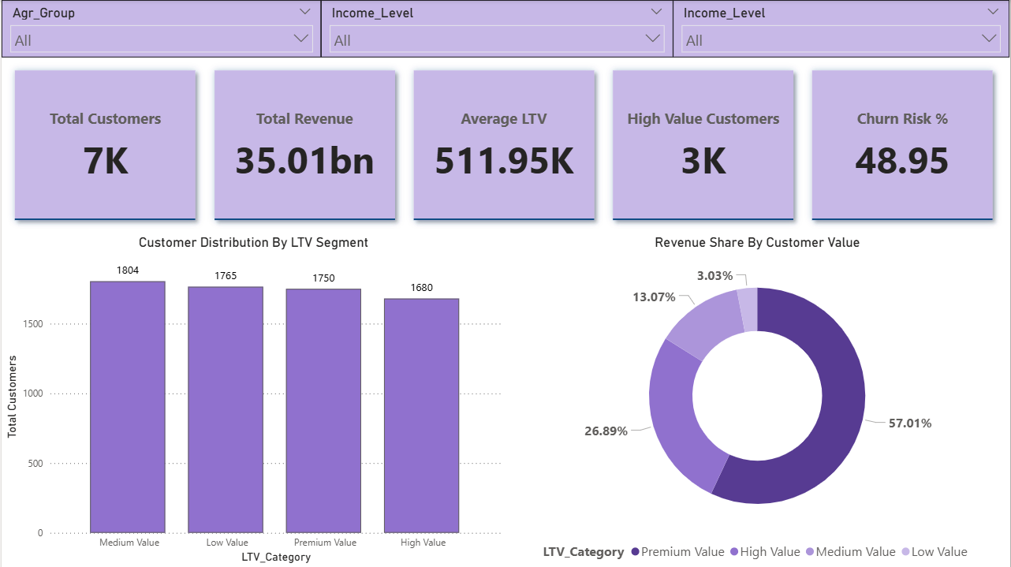

Dashboard 2: Customer Value, Loyalty & Referrals Analysis
- Average LTV by Loyalty Segment
- Revenue contribution by Referral Segment
- Customer value distribution by Loyalty Segment
- LTV by demographics (Age Group × Income Level matrix)
Purpose: Understand what drives customer value.

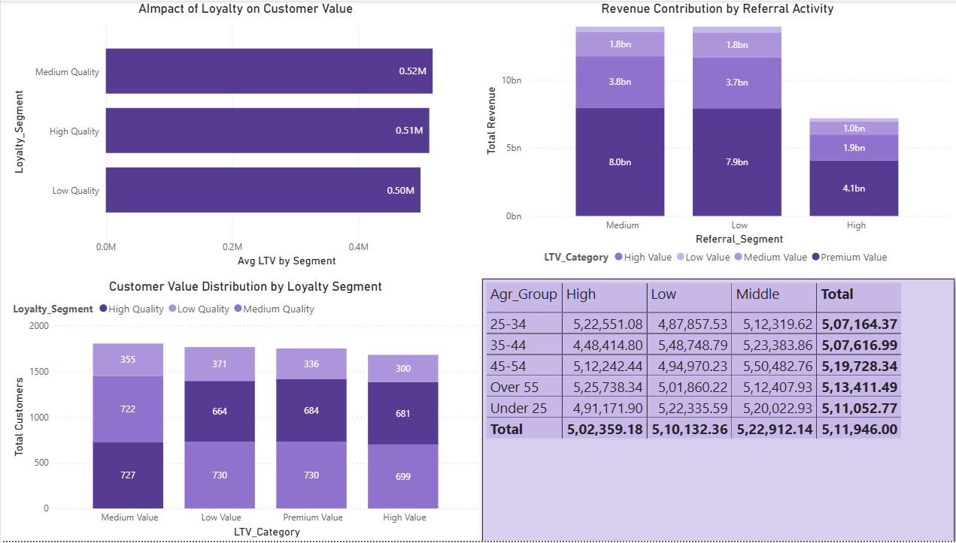

Dashboard 3: Churn Risk & Customer Experience Insights
- Churn risk across LTV categories
- High-value customers at risk (KPI card)
- Churn risk by customer support ticket load
- Satisfaction level vs churn risk (heatmap)
Purpose: Identify risk drivers and retention priorities.

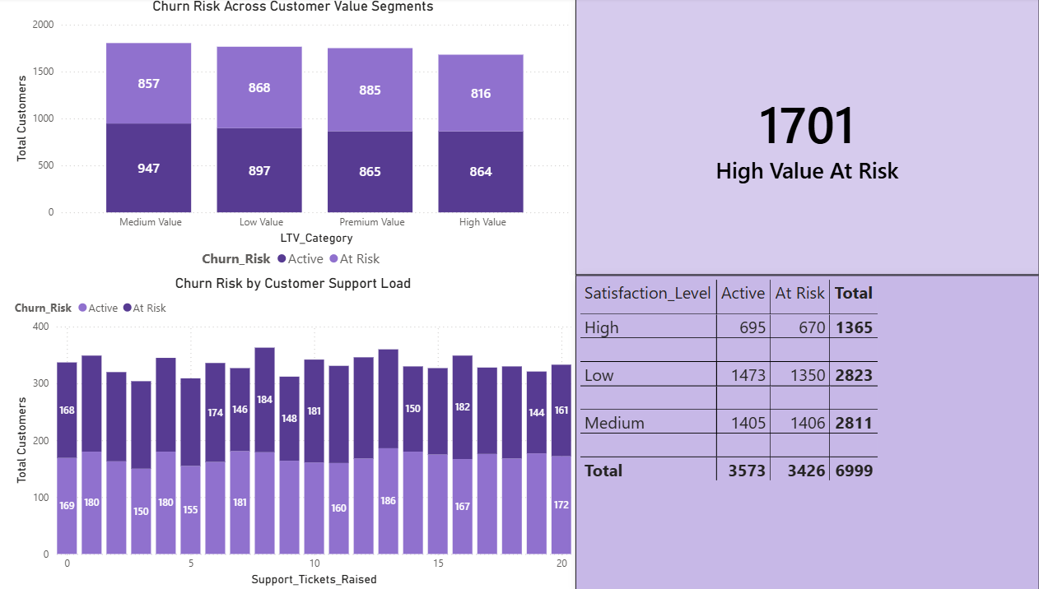

Key Insights:
- High-value and premium customers contribute a disproportionate share of revenue
- Loyalty programs are strongly associated with higher customer value
- Referral activity influences total revenue more than average LTV
- A significant portion of high-value customers are at churn risk
- Higher support ticket volume correlates with increased churn risk
- Lower satisfaction levels show higher churn concentration

Business Recommendations:
- Prioritize retention campaigns for high-value at-risk customers
- Strengthen loyalty programs to sustain high-value segments
- Improve customer support efficiency to reduce churn risk
- Use satisfaction scores as an early warning signal for churn
- Focus referral incentives on segments driving the highest revenue

Conclusion:
This project demonstrates an end-to-end analytics workflow, from raw data to executive-ready dashboards, highlighting real-world skills in SQL, Power BI, data modeling, business analysis, and storytelling.

